cid:image001.jpg@01D08C06.F342D440

CRANLEIGH SCHOOL EQUESTRIAN CENTRE

RIDING SCHOOL HANDBOOK 2019

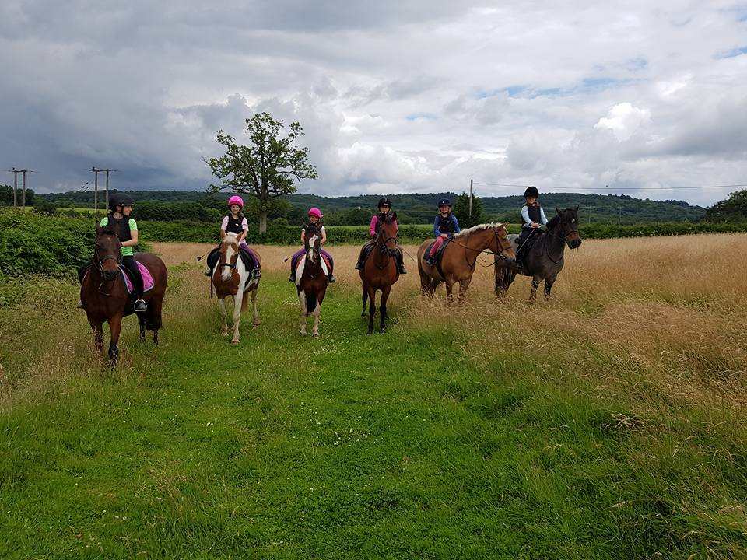

**CONTENTS**

1. INTRODUCTION
2. THE EQUESTRIAN CENTRE STAFF AND CONTACTS
3. LESSONS AND PRICELIST
4. FIRST AID & ACCIDENT POLICY
5. CODE OF CONDUCT
6. PONY CLUB
7. EVENTS AND ACTIVITIES
8. WHAT TO WEAR

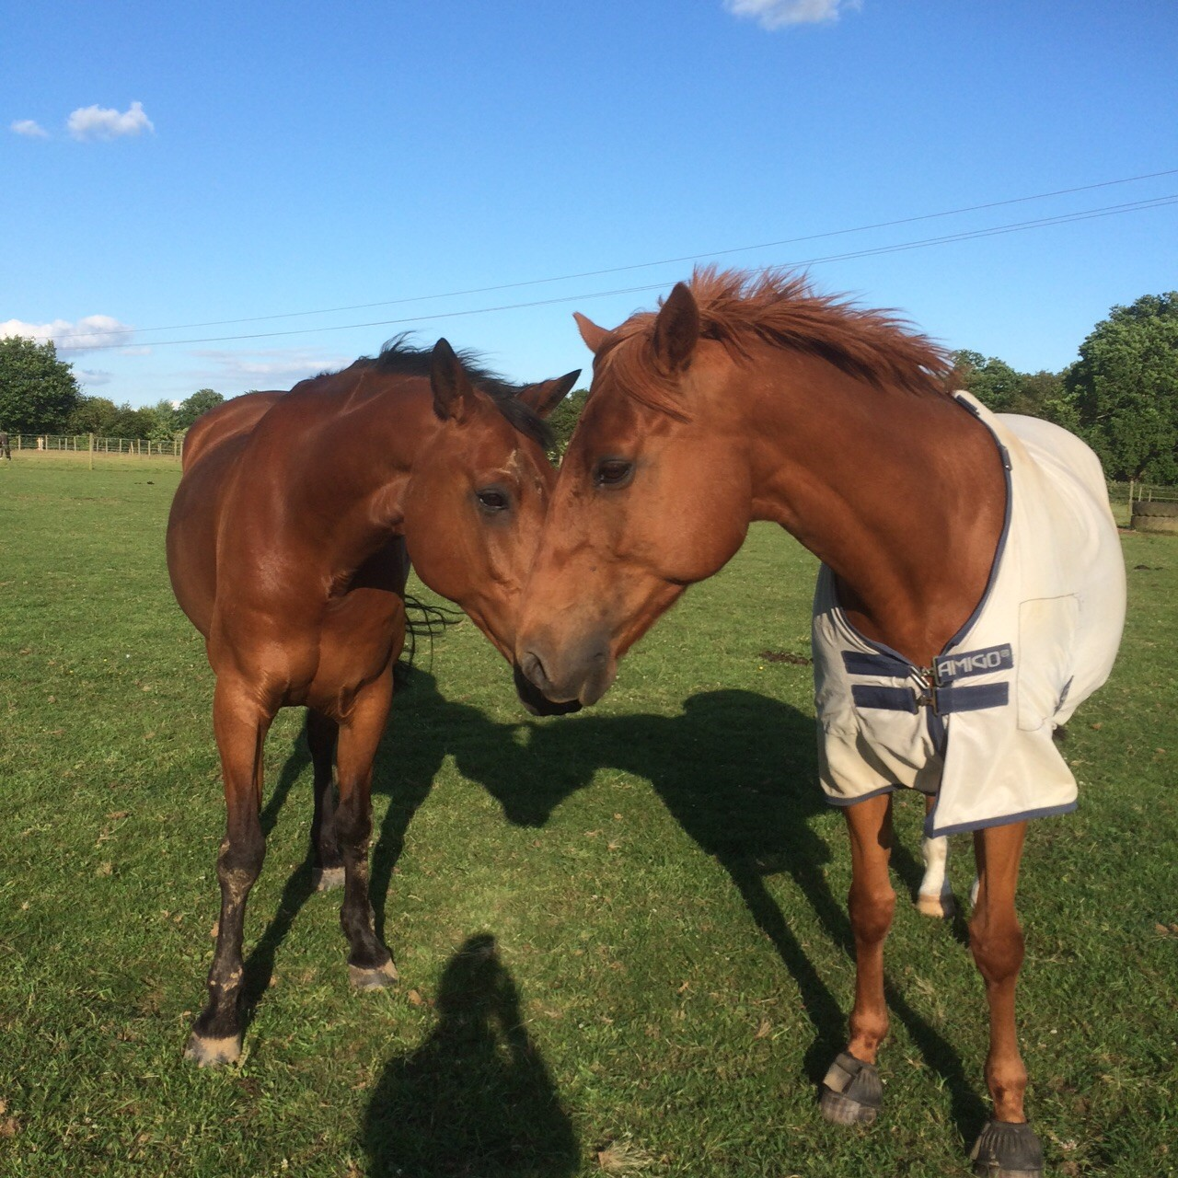

1. **INTRODUCTION**

Cranleigh School Equestrian Centre offers external lessons after school during weekdays and private and group slots at the weekend, for all abilities. We run a variety of lessons from 20 minute walk outs for ‘Tiny Tots’, 45 minute private lessons and hour group lessons. Our lesson prices start from £15.00. All our clients are matched by ability, not age, which we find allows them to get the most out of their lessons. The Riding School has a wide variety of horses and ponies, from 12hh to 17hh, so there should be a suitable mount for everyone!

Our facilities include two sand schools- one 30m x 60m and one 20m x 40m, both with floodlights, as well as a small country courses with fences ranging from 50cm to 70cm. We can also offer dressage and show jumping on grass through the summer months.

Please do read this Handbook carefully as it will help with a number of questions you may have about riding at Cranleigh.

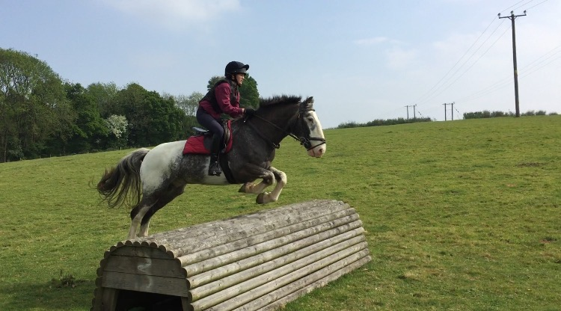

**2. THE EQUESTRIAN CENTRE STAFF AND CONTACTS**

**FRAN MITCHELL BHSAI** oversees the daily running of the Centre making sure that behind the scenes the yard is complying with regulations. She is also in charge of the Riding School admin.

**EMMA EDWARDS BHSAI** is in charge of the livery yard here at Cranleigh School and teaches lessons on Saturdays and some weekday evenings.

**JESS AYRE UKCC Level 2** is our Riding Instructor here at Cranleigh and teaches our Pony Club clients.

**CONTACTS**

Cranleigh School Equestrian Centre

Cranleigh School

Horseshoe Lane

Cranleigh

Surrey

GU6 8QQ

Direct line telephone: 01483 276426

Fran Mitchell [flm@cranleigh.org](mailto:flm@cranleigh.org)

Jess Ayre jla@cranleigh.org

Emma Edwards [ele@cranleigh.org](mailto:livery@cranleigh.org)

Riding School [riding@cranleighactivities.org](mailto:riding@cranleighactivities.org)

1. **LESSONS AND PRICELIST**

Cranleigh Equestrian Centre requires clients to block book all **weekend** riding lessons; you will be required to book a minimum of three lessons over a six week period and these lessons must be paid for in advance.

Bookings are taken for 3-6 dates at a rate of £30 per lesson per booking form. We ask that you remain on your established weekend day and we will endeavour to keep lesson times the same for each week; we will inform you in advance of any changes.

Additional lessons can be arranged with Equestrian Centre staff if space permits. These will be payable at the time of booking.

There will be no refunds for lessons that have been pre-booked. Swapping dates after the cut-off date is at the discretion of the Equestrian Centre Manager.

**Cancellation Policy:** If possible, we require 48 hours’ notice of cancellation. The notice must be given in e-mail form to both Fran on [flm@cranleigh.org](mailto:flm@cranleigh.org) and [riding@cranleighactivities.org](mailto:riding@cranleighactivities.org). Please be aware that we will only carry forward ONE payment per block booking for illness, with the exception of a broken bone, in which case the remainder of the payment would be carried over to the next block. If a lesson is cancelled for any reason other than **illness,** the payment cannot be carried forward.

**Prices**

* Tiny Tots Walk Out: £15 per rider, 5 years+ (20 minutes)
* Pony Club Stable Management Sessions: £20 per member (1 ½ hr)
* ½ Hour Private Lesson: £30
* 45 Minute Private Lesson: £40
* 45 Minute Shared Private Lesson: £30 per rider
* 1 Hour Group Lesson: £30 per rider
* Fun Days: £40 per child. 10am-1pm
* All Day Pony Club Rally: £70 per member
* ½ Day Pony Club Rally: £40 per member, AM or PM

1. **FIRST AID AND ACCIDENT POLICY**

As CSEC is a potentially high risk area, all staff have passed a ‘First Aid at Work’ course. There is a first aid box located in the Staff Room. If an emergency arises, a member of staff will either telephone the School Medical Centre or the First Aid Responder or dial 999. A copy of the Cranleigh School Health and Safety Policy (Full) dated August 2015 is available for clients at the Equestrian Centre. An Accident Form is then completed and logged.

In the case of Fire - the yard has a fire procedure in place and this is held at the yard. All clients are welcome to read it.

1. **CODE OF CONDUCT**

* A quiet relaxed atmosphere is essential for the well-being of the horses. No running, shouting or screaming is permitted on the yard
* Correct footwear is to be worn on the yard at all times (no flip-flops, open-toed sandals or soft canvas shoes)
* No smoking in the yard or the surrounding areas (including visitors and parents)
* Litter should be placed in bins
* All gates must be shut at all times, including field gates, even if they were already open
* All droppings on the yard are to be picked up along with any hay or mud from picking out feet
* To prevent back injuries and to keep the yard tidy, hay and bedding must always be carried in a wheelbarrow



1. **PONY CLUB**

Cranleigh is also a Pony Club Centre and therefore offers opportunities for non-pony owners to become Pony Club members and take part in Pony Club activities, including training towards Achievement Tests and Badges. Membership is open to anyone under the age of 21 years. Many Centres also take teams to Area Pony Club competitions and perhaps qualify for the National Pony Club Championships! To become a member of Cranleigh School Pony Club and for additional information regarding The Pony Club please look at [www.pcuk.org](http://www.pcuk.org)

Throughout the year we run numerous mounted and unmounted Pony Club rallies which allow our members to work towards specific badges and Achievement Tests (from E Test to C+ Test). We also host clear round jumping and gymkhana fun mornings during the holidays.

Pony Club sweatshirts are available to purchase [here](https://www.gggear.co.uk/childrens-cranleigh-school-navy-sweatshirt-762b-98276-p.asp)



1. **EVENTS AND ACTIVITIES**

**Pony Camps**

During the summer we run non-residential camps for Beginner, Intermediate and Advanced riders.

Beginner Camps are for riders who can ride off the lead rein in the school in walk and trot and are working towards canter. They give children a chance to improve their riding as well as learn some stable management. There is the opportunity to take part in a tailored competition on the last day which parents are welcome to come and watch.

Intermediate Camps cater for our riders who are jumping, and give them not only the opportunity to improve their riding skills but the chance to learn new stable management skills as they look after a pony as ‘their own’ for three days. Camp culminates in a competition which all the parents are invited to come and support and the aim is for the children to have fun as well as enjoy a low-key competition with the chance for all of them to win rosettes.

Advanced Camps run over four days and includes the chance to focus on dressage, show jumping and arena eventing. The riders work towards participating in a competition on the last day, which includes a dressage test as well as riding both show jumping and arena eventing courses. The competition is always enjoyed by everyone, with riders supporting each other through the various phases as well as helping with the turnout of each other’s ponies.

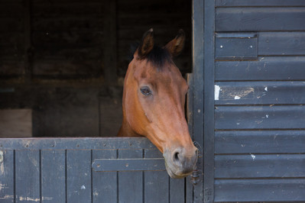

1. **WHAT TO WEAR**

When riding, riders must be correctly dressed, to include:

* Jodhpurs if possible. Otherwise trousers without seams.
* Jodhpur Boots or long riding boots if you have them.
* A hat complying to minimum safety standards: BSI Kite mark PAS015:1998, or Snell E2001 with the official Snell label and number, or SAI Global AS/NZS 3838 1998 or AS/NZS 3838 2003. Due to a change by the European Commission regarding EN1384 and BSEN1384 no longer being an accepted standard, all hats which **ONLY** meet the standard EN1384 or BSEN1384, and do not comply with another accepted standard **WILL NOT** be permitted for use. Hats which bear EN1384 or BSEN1384 **ALONG WITH** another accepted standard, will be permitted. For example, BSEN1384 & PAS015 (1998 or 2011) along with the Kitemark will be acceptable, but not BSEN1384 on its own.
* For XC a skull cap must be worn that does not have a fixed peak.
* 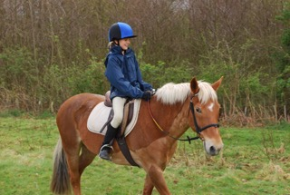It is recommended that long-sleeved tops and back protectors are worn for jumping activities. Back Protectors and long sleeves must be worn for XC lessons.
* Gloves are recommended.
* No jewellery is to be worn.
* Long hair must be tied back.

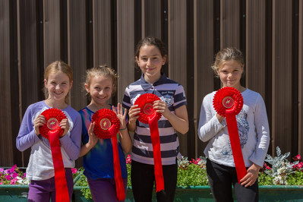

**FINALLY...**

Finally, if you have any queries regarding the above please do not hesitate to contact the CSEC staff on 01483 276426 who will be happy to assist with any questions you have.